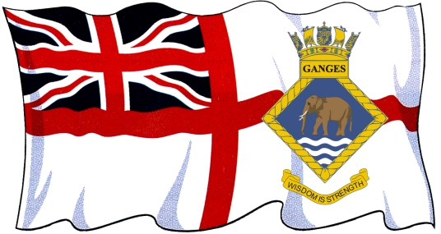








STANDING ORDER MANDATE

Please complete in BLOCK CAPITALS and in black ink.

To: (Name of Bank)___________________________________________________

Address:____________________________________________________________

Please set up following Standing Order and debit my account accordingly.

1. Account details:

Account Name__________________________________________________

Account No.:__________________________ Sort Code_________________

HMS Ganges Membership No:______________________________________

2. Payee details:

Name of Organisation you are paying: HMS Ganges Association

Bank: Barclays Bank PLC, 66 High Street, Ashford, Kent TN24 8TL

Account Number to be credited: 50395838

Sort Code: 20-02-62
3. Please pay the HMS Ganges Association

Amount of first payment: Twenty Pounds (£20) to commence on

(date of first payment)______________________________ annually on this date until further notice.
(payments will be made until this instruction is cancelled).

Signature:_____________________________________________________

Date:_________________________________________________________

For attention of Bank:

Please ensure that the Account Holders Name and HMS Ganges Membership number are quoted at the reference when processing this Standing Order.

